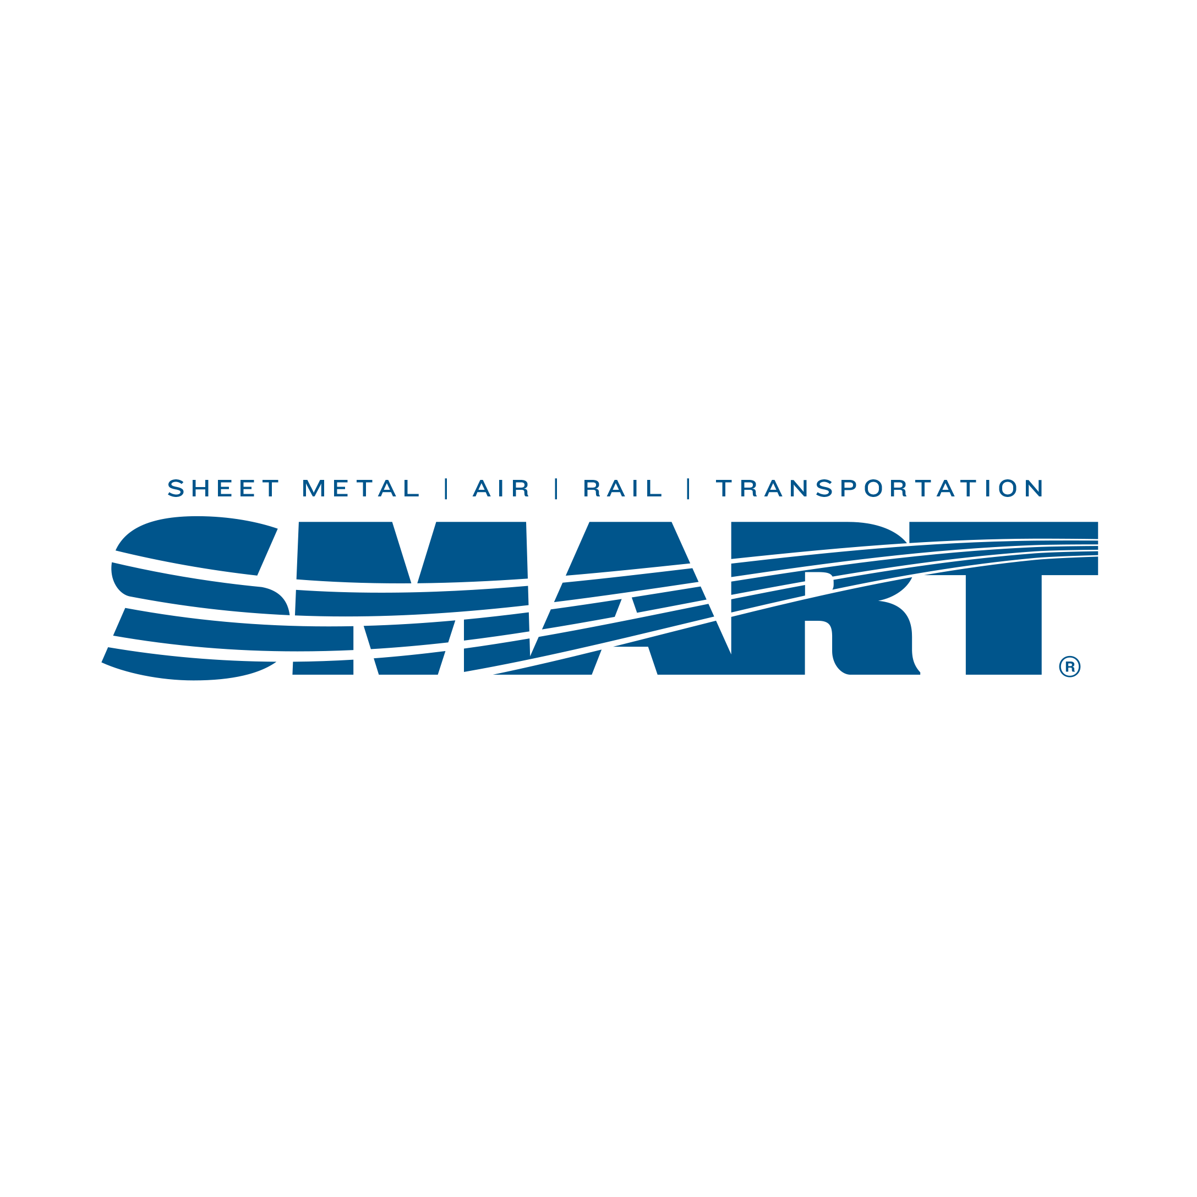

September

D

Local Union # 83

900 Commerce Drive Phone: (518) 489-1377

Clifton Park, NY 12065 Fax: (518) 453-9284
www.smartlu83.org

December 2023 Newsletter

The Annual Christmas Party will be held after our December Meeting on Thursday, December 14, 2023 at 4:30pm. We hope you will join us this year for some good food and holiday cheer.

From the desk of Business Representative John Shustz
I continue to work with International Representatives/Trustees John Christiansen and Larry Kinzie on some of the issues we have had on winning work in an effort to keep our members employed. We have several members, as well as retirees, that have taken the call to travel across the country to several Job Bank calls needing Union workers. These jobs offer substantial travel incentives making it hard to pass up. If you are interested, please contact me at (518) 709-3691. On behalf of the Officers and Staff, I would like to wish you all a very Merry Christmas and Happy New Year!

Are your DUES paid? If your dues are current and you worked less than 650 hours from July 1 -December 31, 2023 you may be eligible for SASMI. You will need copies of your NYS Unemployment pay history, 2023 W-2s and a completed SASMI application to apply. Please call the hall at extension 304 and we can mail one to you. Applications cannot be submitted until AFTER January 2, 2024.

Are you aware of Union Plus? If not, check it out! www.unionplus.org. Discounts…on your cell phone thru AT&T; Discounts on flowers thru a Teleflora florist (and you can choose a local florist). How about an auto rebate when you purchase a union made vehicle? Hardship help; Shopping & discounts; Credit counseling; Save my Home Hotline and so much more! We have included a flyer from Union Plus to get you started.

NEW FACEBOOK PAGE – Due to staffing changes and the inability to reset the password on the original Local 83 Facebook page, we have created a new page. Please go to https://www.facebook.com/profile.php?id=100090993437934

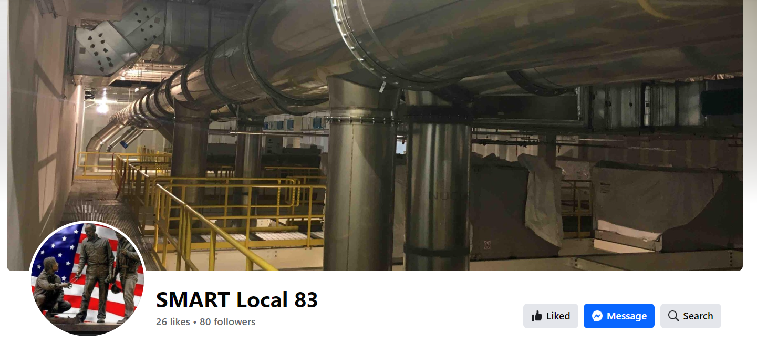

INSURANCE NEWS: See the enclosed Open Enrollment letter. We are happy to report there are no big major changes this year for active members. Members should continue to use their Highmark cards issued last January for both medical and prescriptions. Delta Dental continues to provide coverage for your dental.

The Insurance Fund continues to reimburse for vision and hearing care. Members can be reimbursed 80% up to $350 every 18 months for vision (this changed July 1, 2023) and includes an exam, eyeglasses and/or contacts for you and your eligible dependents. Hearing care benefits are provided for active members, their dependent children, and retirees. The fund reimburses $1200 every 30 months, subject to a $50 deductible.

Lastly, and most importantly, the Insurance Fund provides an anonymous MAP (Member Assistance Program, formerly known as Employer Assistance Program) to its members at NO cost. Please use it! We pay a flat annual rate, and we never receive any information as to who uses it or not. Members and their families can call the MAP (800-252-4555) or log onto the website at www.unionap.com for thousands of articles, videos, and tools to help you resolve personal problems. Find information on thousands of topics including but not limited to: Alcohol and Substance Abuse, Smoking Cessation, Adoption, Financial Planning, Mental Health, Will Templates, Divorce, Home Ownership, Loss & Grief, Stress, Childcare, and Work-Life Balance. See the enclosed brochure.

Please note the 2023 Holiday Office Hours:
- Christmas Eve. observed, Friday, December 22, 2023, closed at noon.
- Christmas Day observed, Monday December 25, 2023, CLOSED
- New Year’s Eve. observed, Friday December 29, 2023, closed at noon.
- New Year’s Day observed, Monday January 1, 2024, CLOSED

Please make arrangements to have your dues paid by
Friday, December 29, 2023 by 12 noon.

