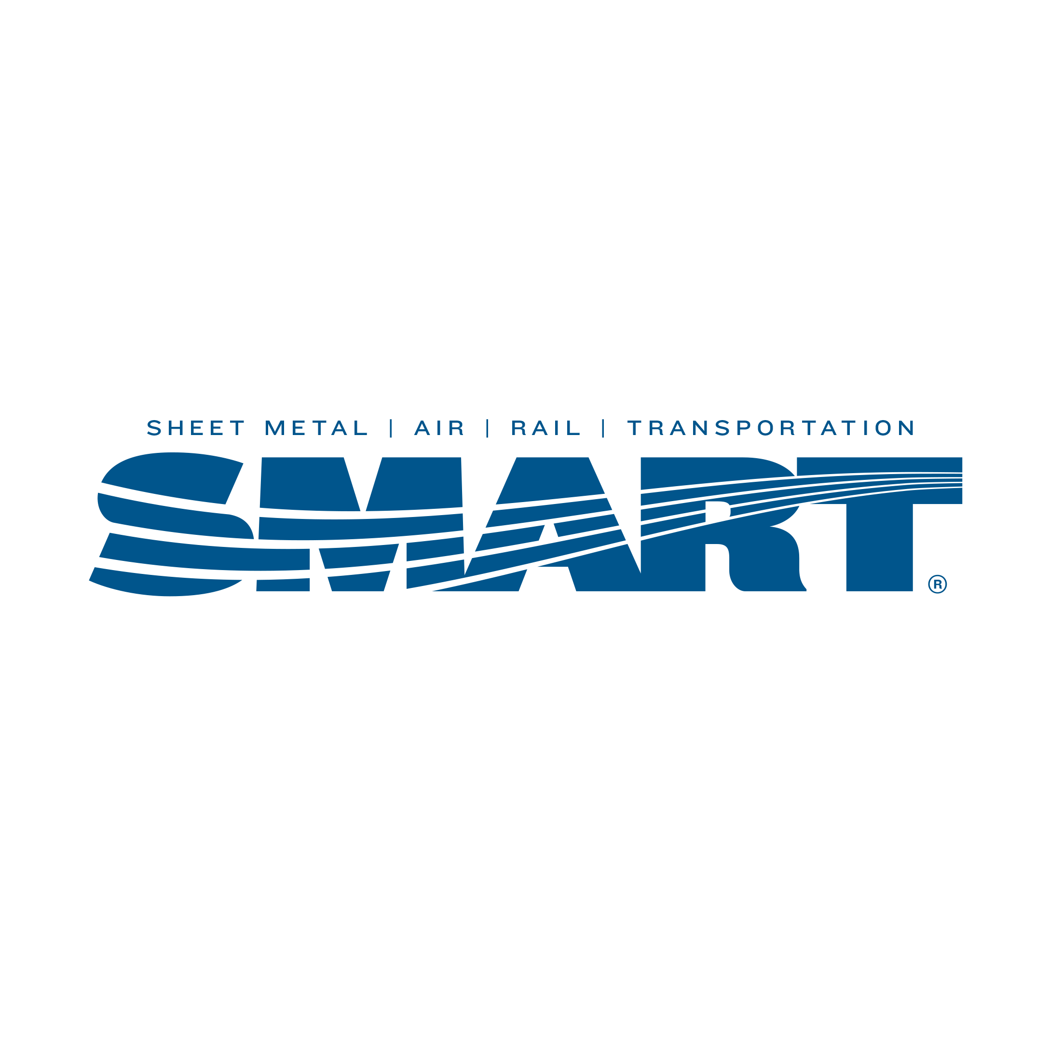
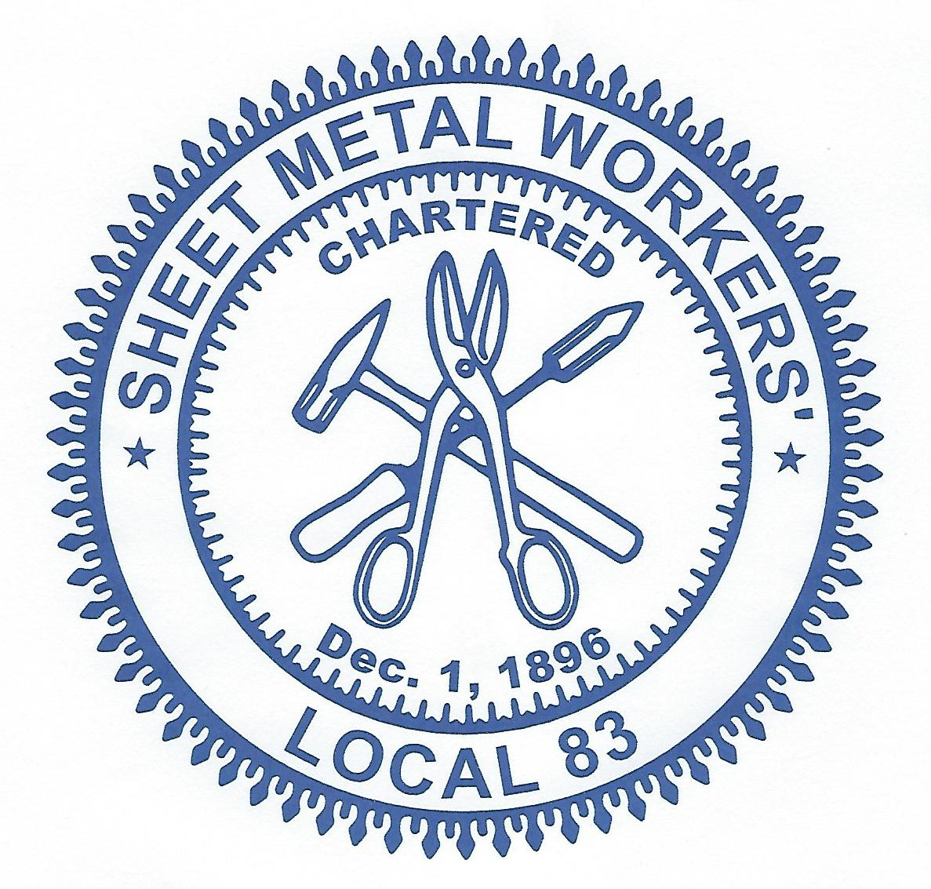

Local Union # 83

900 Commerce Drive Phone: (518) 489-1377
Clifton Park, NY 12065 Fax: (518) 453-9284
www.smartlu83.org

April 2023 Newsletter

Our next regular meeting will be held on
Thursday, April 20, 2023, at 5pm.

The Roll–over raffle for the April 2023 regular meeting is $200.00.

Annuity Advisor Matt Kapanek will be attending this meeting
to give a presentation and answer questions.

From the desk of John Shustz:

Work should be picking up as we get closer to summer. There are quite a few bigger jobs with PLA’s which will keep us busy through fall/winter and into next year. If anyone is looking for work or is running out of unemployment there are numerous Job Bank calls that are offering SASMI travel incentives, plus contractors/jobsites are also offering additional travel incentives in order to cover the jobs. If you are interested, feel free to contact me at 518-709-3691 and I can answer any questions.
If you get laid off or go back to work please give me a call!!!!

Aaron Donnelly, Organizer/Marketing Representative:

Social Media: Anyone who uses Facebook please look for our new Union page called “SMART Local 83” and follow it. The current page called “Sheet Metal Workers Local 83” will eventually be inactive because we no longer have administrative control over the old page.

SMART Army: The VFW in Fonda needs our help installing gutters in the spring. We have already helped them get heat this winter after they were stiffed by a couple of contractors and now they are asking for our help again. One of their members came to a building trades meeting asking for everyone’s help, we are not the only trade helping them get their facility to function better as it’s an old building. Any persons willing to donate a few hours of their time for this or for any volunteering needs, please reach out to me so I can build a list of people to call and help our community.

SALTING: If you are out of work and are willing to Salt for the Union, please call me. You must complete a short Salting class with me then afterwards we can work out a plan on how to move forward. You may call me at: 518-368-4488 or email me at: adonnelly@smartlu83.org

From JATC Administrative Coordinator Larry Hebbard:

We currently have 30 apprentices in our program with the 4th term of the school year in progress and moving along well.

As I mentioned in past newsletters in order to keep the apprentices trained in all aspects of jobsite safety and continue to reach out for all work opportunities we will continue doing; Haz 40, Hoisting & Rigging, OSHA 30 and Asbestos awareness training in our apprentice training program.

I want to give thanks to 3 students; Conor Compton – Welding, Grant Lamoy – 2nd year & Vernon Howe – Architectural that will be participating in this year’s region 1 contest and representing Local 83 on April 20-22 in Buffalo, New York. Best of luck to all of them.
In an effort to expand our current training program, if you are member in good standing that would be interested in committing your time to possibly teach; please contact me to review details as to what it would entail, a resume would be required. We are especially interested in members with TAB and Architectural experience, but all inquiries are welcome. These positions require that the individual be available for 15 nights, 2 nights a week from 5-8 which is the length of a class commitment.

We are putting on a 6-hour training class for Scissors and Boom lifts which will be held on Saturday April 15, 2023 at 8:00 AM at the Union hall. There are 8 slots available on a 1st come 1st serve basis. All that complete the class satisfactory will receive training certificates.

You must register with your $100.00 refundable deposit by April 10, 2023 contact Angela Grant at the office to sign up.

From CWI Paige Bright:

Attention all Welders: I have been updating the Welder List on the Local 83 website quarterly. Please log onto the website at smartlu83.org to check the expiration dates of your certifications and to ensure they do not expire! A large portion of certifications will be expiring within the next few months so please make sure you submit your renewal form to me beforehand. IF YOUR CERTIFICATION IS EXPIRING BETWEEN MAY 12TH - MAY 28TH: Please make sure your renewal form is submitted to me by May 11th AT THE LATEST. I will be out of the country during this time and will NOT have access to the database to update certifications. I will attempt to reach out to those whose certifications expire within this time frame, however, I am aware TotalTrack does not always contain up to date contact information. Please reach out to me by sending an email to pbright@smartlu83.org. As always, if you have any questions, please do not hesitate to contact myself or Larry Warzek. Thank you.

From Angela, Donna & Marilyn:

It’s just junk……or is it? We have been getting a great deal of calls from our members stating that they did not get their new insurance card, or they were not aware that we got new insurance cards. We have also mailed out checks at different times from both the Union and Marshall & Sterling and checks have remained uncashed because your mail is not being opened. It is imperative that you open your mail!!

We have sent some important mailings out in the past few months. Make sure to OPEN and to read your mail to keep up with the latest insurance information and documents and also important meeting dates.

Fraternally,
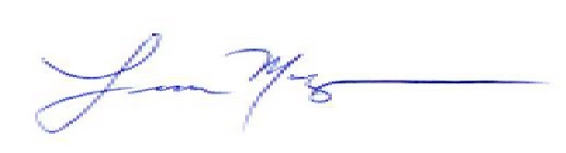
Frank Maguire
President/Business Manager

