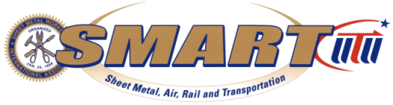
International Association of Sheet Metal,
Air, Rail & Transportation Workers Local Union 83
Retiree’s Association

900 Commerce Drive Phone: (518) 489-1377
Clifton Park, New York 12065 Fax: (518) 453-9284
E-Mail: lhebb2@nycap.rr.com

Sheet Metal Workers Retiree’s Meeting
MARCH 8, 2022 @ 10:30 am

Local 83 Retirees:

This month’s meeting will be held, at our Union Hall located at 900 Commerce Drive, Clifton Park, NY 12065. Exit 10 off the Northway. (87)

I hope all are doing well and it is that time to get together, hopefully you can join us for this month’s meeting at which time you can get updated on what has been going on at Local 83

This month we will be having lunch with light refreshments. We have a standing motion made by the body, to have the retiree’s treasury pay for the meals for those that attend.
.
****If you plan to attend the meeting, please call the office at (518) 489-1377 ext. 305 to let Angela know so she we can determine how much seating to plan on.

We continue to look for donations which will go on the 2022 calendar year. Our club only asks for $8.00 per year from each retiree. To those that have already donated we are very appreciative.

Please mail your check made payable to SMART LU #83 Retiree’s Association to:

Larry Hebbard, 107 Independence Drive, Ballston Spa, NY 12020 or

SMART LU 83, 900 Commerce Drive, Clifton Park, New York 12065

Our organization remains an active voice for all retirees since 1983.
YOUR ATTENDANCE IS GREATLY APPRECIATED.

Respectfully
Lawrence Hebbard
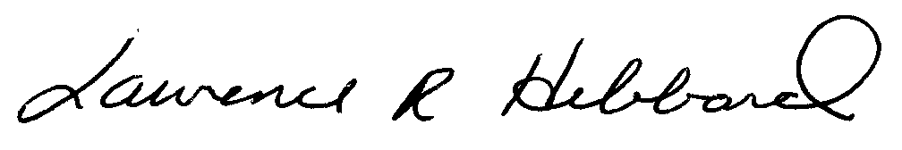
Secretary /Treasurer
Local #83 Retiree’s Association

