International Association of
Sheet Metal, Air, Rail & Transportation Workers
Local Union 83 Retires Association
900 Commerce Drive Phone: (518) 489-1377
Clifton Park, New York 12065 Fax: (518) 453-9284
E-Mail: lhebb2@nycap.rr.com

Sheet Metal Workers Retiree’s Meeting/Luncheon

JUNE 9, 2020 MEETING CANCELED

Due to COVID – 19, the June meeting is canceled

If conditions permit our next meeting will be September 8, 2020

We continue to look for donations which will go on the 2020 calendar year. Our club only asks for $6.00 per year from each retiree. To those that have already donated we are very appreciative.

Please mail your check made payable to SMART LU #83 Retiree’s Association to:

Larry Hebbard, 107 Independence Drive, Ballston Spa, NY 12020 or

SMART LU 83, 900 Commerce Drive, Clifton Park, New York 12065

Our organization remains an active voice for all retirees since 1983.
YOUR ATTENDANCE IS GREATLY APPRECIATED.

Respectfully
Lawrence Hebbard
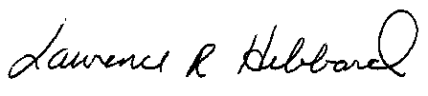
Secretary /Treasurer
Local #83 Retiree’s Association

