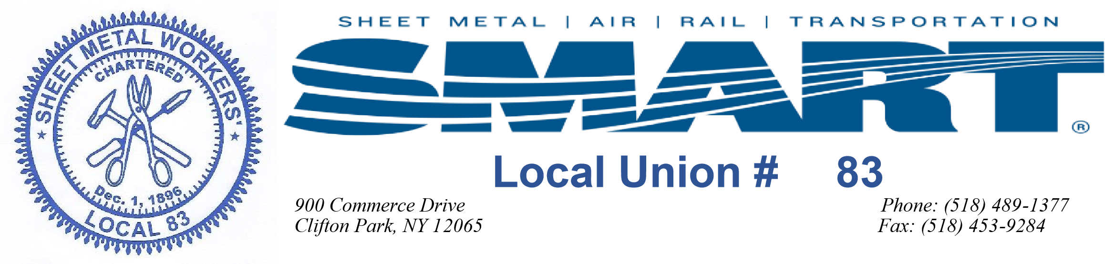
Annual SMART Local 83 Steak Bake
Colonie Town Park, 71 Schermerhorn Road, Cohoes, NY 12047

August 29, 2020

Ticket Order Form
Enclosed is my check in the amount of _______ for the following:

Please indicate the number of dinners required:

_______ Adult Steak Dinners ($40.00 each) _______ Adult Chicken Dinners ($40.00)
_______ Children under 12 ($15.00 each) _______ Children under 5 (Free)

Name (please print) ______________________________________
Please make checks payable to:
SMWLU #83 Entertainment Fund
Mail to: 900 Commerce Drive, Clifton Park, NY 12065

Please Note: If you would like to compete in the annual horseshoe tournament it is imperative that you sign up by 1:25 PM to be entered.

The Sheet Metal Workers Local Union #83 Entertainment Committee thanks you for your continued support of our Steak Bake and look forward to seeing you on August 29, 2020.

If you are a member and purchase a ticket you will be reimbursed for your ticket only if you sign in to the picnic. If you do not sign in you will not be reimbursed!!

If you have purchased a ticket for another member it is their responsibility to sign in. If they do not sign in, no reimbursement will be made regardless of who paid for the ticket.
Please note that this year’s steak bake has been moved to a new location:
Colonie Town Park, 71 Schermerhorn Road, Cohoes, NY 12047

