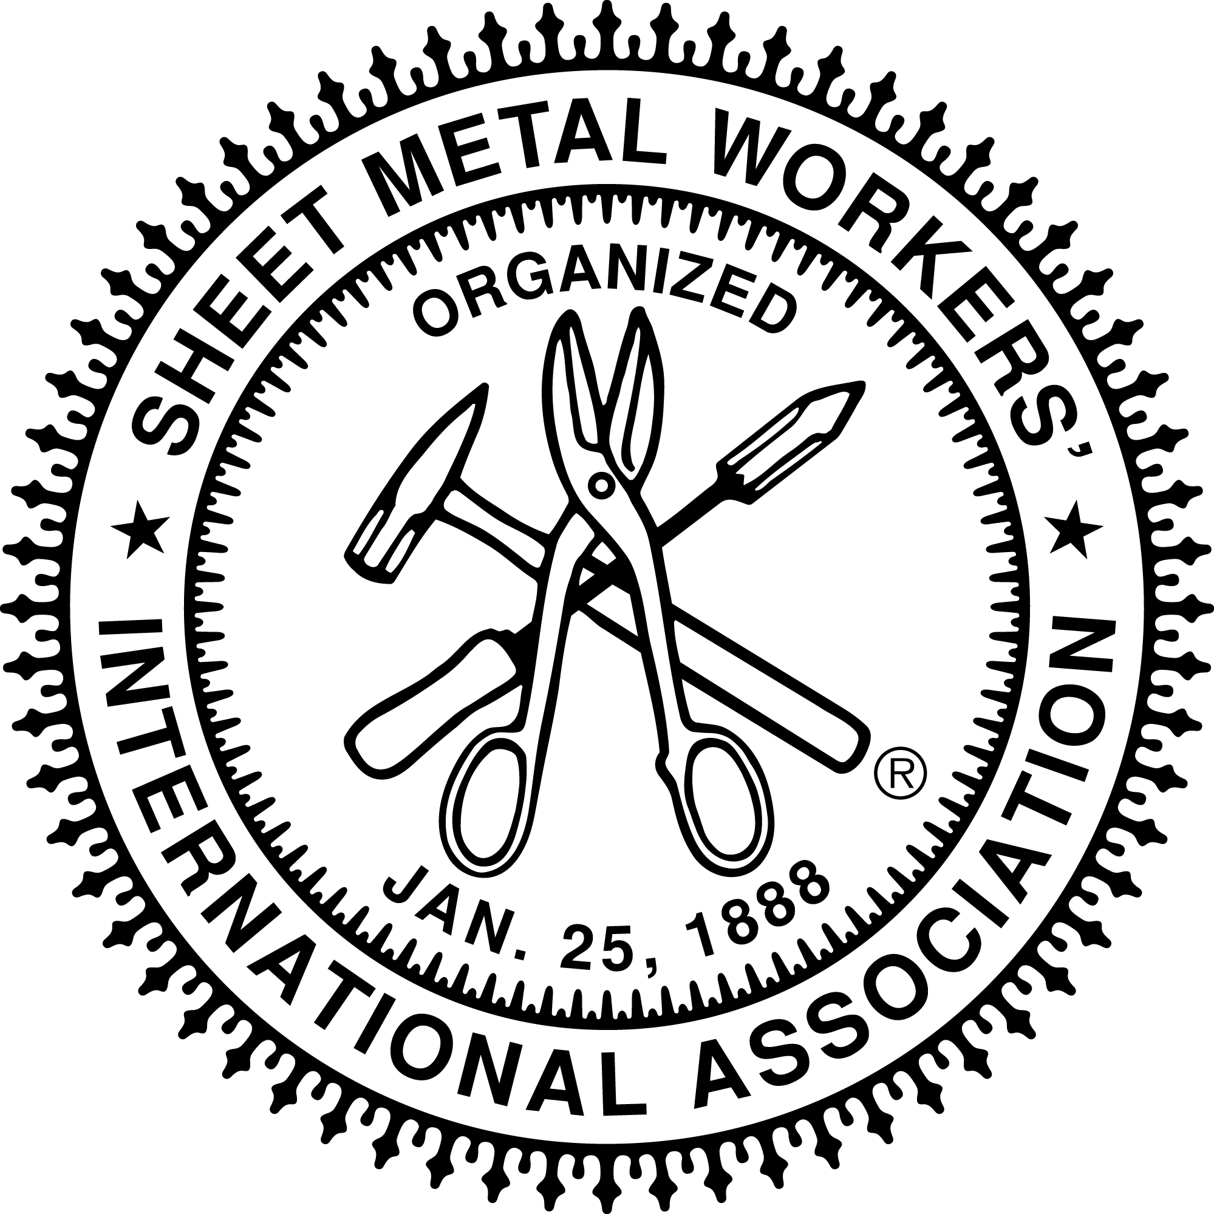
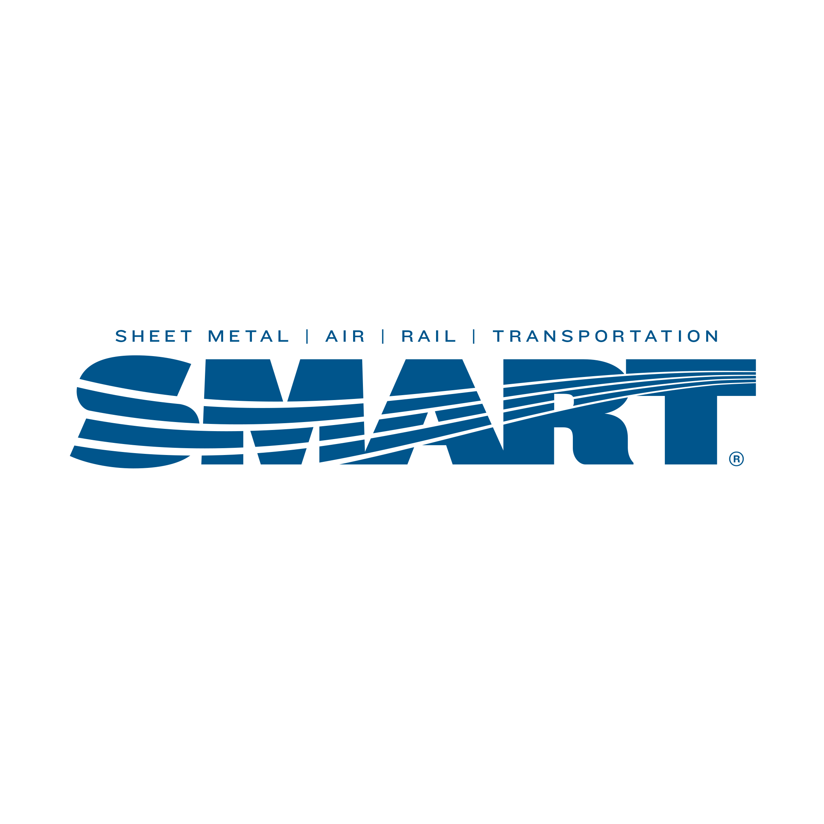

Local Union # 83

900 Commerce Drive Phone: (518) 489-1377
Clifton Park, NY 12065 Fax: (518) 453-9284

Contractors Affiliated with Local #83
(see below for letter code references)

Ackroyd Metal Fabricators, Inc.
966 Broadway
Albany, (Albany County), NY 12204
Phone: (518) 434-1281 (A) (B) (C) (G) (H) (M)
Fax: (518) 434-8232

Adirondack Air Balance Co. (Paul Zabinski)
342 Clendon Brook Road, Queensbury (Warren Co.), NY 12804
Phone: (518) 798-6186 (A) (L)

Borders Mechanical, LLC
8463 State Highway 56
P.O. Box 492
Nolfolk, NY 13667
Phone: (315) 384-6137 (A) (B) (C) (G) (K) (N) (O) (Q)
Fax: (315) 384-6134

Cerniglia Metals, LLC.
17 Smith Road
Petersburgh, NY 12138
Phone: (518) 698-0642 (A) (B) (C) (G) (K) (N) (O) (Q)

Danforth (John W) Company
- Liebich Lane,
Halfmoon, NY 12065
Phone: (518) 400-1600 (A) (B) (C) (G) (K) (N) (O) (Q)

Elmsford Sheet Metal Works Inc.
23 Arlo Lane
Cortlandt Lane, NY 10567
Phone: (914)739-6300(A) (B) (C) (G) (K) (N) (O) (Q)
Fax (914)739-6300

Industrial Sheetmetal Solutions
PO Box 571, 1 Riberdys Groves Road
Waterford, NY 12188
Phone: (518) 925-3695 (A) (G) (H)

J.E. Monahan Metals, Inc.
559 Queensbury Avenue, Suites 1 & 2, Queensbury (Warren Co), NY 12804
Phone: (518) 761-0414 (A) (B) (C) (G) (K) (N) (O) (Q)
Fax: (518) 761-0520

J.H. Bennett, Inc.
713 Third Avenue, Watervliet (Albany Co.), NY 12189
Phone: (518) 273-6122 (A) (B) (C) (G) (M)
Fax: (518) 273-0808

Kasselman Electric
29 Broad Street
Albany (Albany Co), NY 12202
Phone: (518) 465-4795(A) (G)
Fax (518) 465-4161

K&L Plumbing & Heating INC.
7 Kaycee Loop Road
Plattsburgh, (Clinton Co.) NY 12901
Phone: (518) 563-1980 (A) (B) (C) (G) (K) (N) (O) (Q)
Fax: (518) 563-9226

Kleeberg Sheet Metal Inc.
65 Westover Road
Ludlow, MA 01056
Phone: (413) 589-1854 (A) (B) (C) (K)
Fax: (413) 583-6383

MCD Metal, LLC.
20 Corporate Circle, Albany (Albany Co.), NY 12203
Phone: (518) 456-9694 (A) (B) (C) (G) (K) (N) (O) (Q)
Fax: (518) 456-9664

Mechanical Testing, Inc. (WBE CONTRACTOR)
4 Chelsea Place, Suite 102 Clifton Park (Saratoga Co), NY 12065
Phone: (518) 450-7292 (L)
Fax: (518) 450-7295

MJL Adtek Enterprises, Inc.
PO Box 16144, Albany (Albany Co.), NY 12212
Phone: (518) 218-0497 (L)
Fax: (518) 218-0536

Monahan & Loughlin, Inc.
4 Locust Street, PO Box 311, Hudson Falls (Washington Co), NY 12839
Phone: (518) 747-4191 (A) (B) (C) (G) (K) (N) (O) (Q)
Fax: (518) 747-6625

Northeastern Air Quality, Inc.
730 Third Street
Albany (Albany Co), NY 12206
Phone: (518) 857-3641 (L)
Fax: (518) 689-2256

Northern Mechanical Inc.
2 Baldwin Avenue
Norwood, NY 13666
Phone: (315) 353-1202 (A) (B) (C) (G) (K) (N) (O) (Q)

OCM Construction, Inc.
PO Box 2285
Blasdell, NY 14219

Postler & Jaeckle Corp. Mechanical Contractors
9 Krey Blvd
Rensselaer, NY 12144
Phone: (518) 459-2020 (A) (B) (C) (D) (G) (K) (N) (O)
Fax: (518) 459-2622

Selby & Smith, Inc.
1074 Broadway, Albany (Albany Co), NY 12204
Phone: (518) 436-4136 (A) (B) (C) (G) (K) (N) (O) (Q)
Fax: (518) 436-4138

Technical Building Services, Inc. (TBS)
12E Commerce Drive, Ballston Spa (Saratoga Co), NY 12020-3631
Phone: (518) 885-4444 (A) (P)
Fax: (518) 885-4680

Titan Roofing, Inc. (MBE CONTRACTOR)
32 Railroad Avenue, Albany (Albany Co), NY 12205
Phone: (518) 235-1707 (B) (F) (G)
Fax: (518) 235-1753

VBI, LLC.
606 7th Street, Scotia (Schenectady Co), NY 12302
Phone: (518) 374-0394 (A) (B) (C) (G) (N) (O)
Fax: (518) 688-1152

CODE TO SPECIALTY WORK PERFORMED

- Heating, ventilating
- Heating, ventilating, roofing
- Blow pipe and general sheet metal
- Kitchen equipment
- General sign shop
- Metal ceiling
- General Jobbing or Specialty
- Steel decking general sheet metal
- Toilet partitions cornice, skylight and general
- Lockers and shelving sheet metal
- Spiral or oval duct
- Testing and balancing
- Production shop
- Residential Home Heating
- Light Commercial
- Service Work
- CAD Drafting & design

(WBE) Women– owned Business Enterprises
(MBE) Minority owned Business Enterprises

