
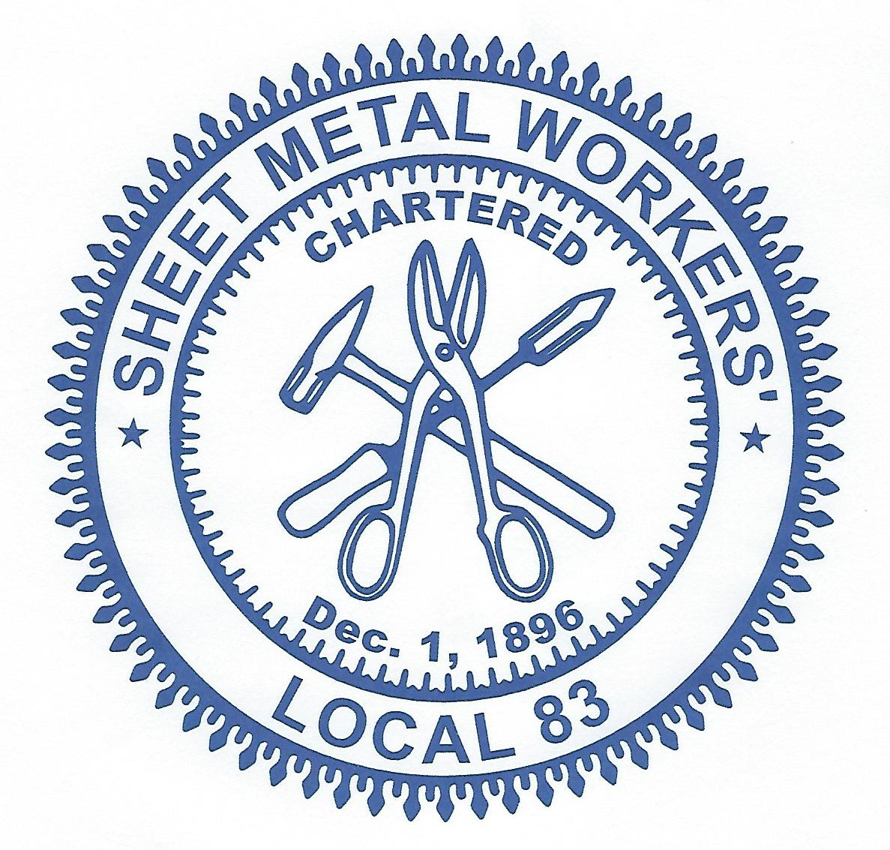

Local Union # 83

900 Commerce Drive Phone: (518) 489-1377
Clifton Park, NY 12065 Fax: (518) 453-9284

November 2018 Newsletter

REMINDER!!!
2018 Service Awards and Apprentice Graduation Celebration &
Retired President / Business Manager Mark B. Landau Honorary Banquet

We take great pleasure in announcing our up-coming Sheet Metal, Air, Rail & Transportation Local #83 Awards Celebration Banquet which will be held on November 17, 2018.

At this time we will honor our members who have maintained continuous membership for 15, 25, 40, 50, 60 & 70 years, as well as the apprentices who have graduated from our program since the last event.

We will also be honoring our retired President / Business Manager-Mark B. Landau for his 27 years of dedicated service to our Local.

FOR MORE INFORMATION please go to our web site at: www.smartlu83.org
and go to News & Events
Cut-off date to attend is November 9, 2018.
Cost is $65 per person for those not receiving an award or graduation.

****Seating is limited so please respond as soon as possible****

The winner of the October 2018 Regular meeting Roll-over raffle of $50.00 was not in attendance.
Another $50.00 will be added for the November Regular meeting roll-over raffle which will be $100.00. All members are eligible for the drawing but must be in attendance to collect.

INSURANCE NEWS:
It is OPEN ENROLLMENT time! ACTIVE MEMBERS, do you know how many hours you need to work each month to pay for your monthly health insurance premiums?

The Fund Office mailed out information for open enrollment for both Active Members and Retirees. Open Enrollment is from November 1st through November 30th. Please review the package you received, review the rate increases, look at your PAP account and evaluate whether or not you need to make a change. Members only need to complete an enrollment form to make a change.

If you have questions or don’t honestly know what to do, please call Donna at the Fund Office 518-489-1377 x304 or Jaeger & Flynn 518-373-0069 x208. WE ARE HERE TO HELP.

From the Desk of Business Representative Jon Barnes:
Please remember to call into the hall if you get laid off or go to back to work so that we can update the book. I can be reached by cell at 518-709-3691 or in the office at 518-489-1377 x 302.

From the Desk of Marketing Representative Phil Stenglein:
November 6th is a very important day for our Country and our Union. It is very important that Union members get out the vote. Local 83, the Building Trades and the AFLCIO have carefully vetted the candidates this year and are endorsing these candidates for their support of the Trades and Unionized Labor. Please consider the following candidates when you go to the polls on November 6^{th.} Our very livelihoods depend on it.

GCRBCTC Candidate Endorsement List:
- Aaron Gladd (SD-43)
- Pat Strong (SD-46)
- Michelle Ostrelich (SD-49)
- Tistrya Houghtling (AD-107)
- Carrie Woerner (AD-113)
- Bill McCarthy (New York Supreme Court – Third Judicial District)
- Margaret Walsh (New York Supreme Court – Third Judicial District)

Also consider: *Anthony Delgado (CD-19) *Anthony Brindisi (CD-22)

**********************************************************************************
The Young Leaders Council is currently collecting donations of any amount to fund their efforts to provide turkeys to 5 different charities! Last year they were able to assist 3, please consider making a donation by November 15th to help. Donations can be dropped at the union hall or given to any member of the Council. For more info contact Phil Stenglein at 518-368-4488 or Pete McDermott at 518-269-7737.

*********************************************************************************
From JATC Coordinator Larry Warzek:
We will be holding an OSHA 30 Training Class. A lot of projects currently are requiring foreman & some workers to have this as a minimum. It would be in your best interest to have this prior, so you are immediately available to work on these sites if it is required. Before we can schedule a class we need to have some idea of how many members would be interested in taking the class. Please call me before December 1, 2018 at (518) 489-1377 x306 or my cell at (518) 258-4176 if you are interested in attending the class. Once we have an idea as to how many people will be attending the class we will schedule. Again this will be a 30-hour OSHA class and a $200.00 deposit will be required when you sign up.

Mark your calendars for upcoming Holiday Hours:
Thanksgiving, Thursday, November 22, 2018 – CLOSED
Friday after Thanksgiving, Friday, November 23, 2018 – Open from 8-12noon
Christmas Eve, Monday, December 24, 2018 – Open from 7-12noon
Christmas Day, Tuesday, December 25, 2018 – CLOSED
New Years Eve, Monday, December 31,2018 – Open from 7-12noon
New Years Day, Tuesday, January 1, 2019 – CLOSED

Please make all necessary arrangements to have your dues paid by Friday December 28th.

Fraternally,

Frank Maguire
President/Business Manager

Enclosures

