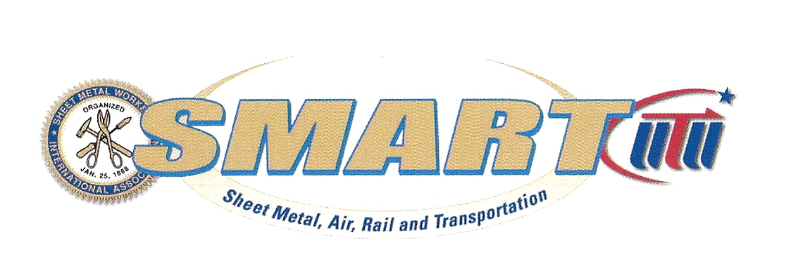

MAY NEWSLETTER

IMPORTANT: this month’s regular meeting will be held at the Polish Community Center, located at 225 Washington Avenue Ext., Albany NY 12205 at 5:30 PM. This is being done being we have 3 special items to address and believe that there will be larger than normal attendance because of this.

- There will be a presentation by Jaeger and Flynn on the PAP accounts and a discussion on the open enrollment period that will begin shortly. That notice will be mailed out in the next few days. They also will answer general questions which might help you make the decision as to whether it would be best for you to stay or change the coverage option you chose last period.
- An election of an executive board member.
- The allocation of the $1.50 p/h increase we shall receive 6/1/2017.

ELECTION:
Recently, another board member has resigned from the Local #83 Executive Board, and it is our understanding that another member may resign in the near future; therefore, we will be having another election.

IN COMPLIANCE WITH ARTICLE 12 OF THE SHEET METAL WORKERS’ INTERNATIONAL ASSOCIATION CONSTITUTION AND RITUAL, you are hereby notified that nominations will take place for an E-board position for Local #83 on May 18, 2017 at the meeting noted above which will be held at the Polish Community Center.

Right after the nominations are made, an election will be held that evening.

If a member holds another elected Union position, they must resign that position in order to go on the ballot.
Just a reminder, to be eligible to be nominated, members must have their dues paid in advance (at least through May), and they must have been an active dues paying member for two years prior to being nominated.

Again: Nominations and elections to fill that position will take place on May 18, 2017, during the regular meeting at the Polish Center.

ALLOCATION:
Enclosed is a copy of the handout that will also be provided at the regular meeting showing assorted options as to how the membership might allocate the $1.50 p/h. These are only suggestions and it is up to the body to determine where the money will go. If you have any questions please call President / Business Manager., Mark B. Landau.

HEALTH INSURANCE- CHILD HEALTH PLUS:
The Insurance Fund Trustees were made aware that coverage under NYS Child Health Plus may be an option for some of the membership. Members currently with family or two person coverage (member plus child) may be eligible for NYS Child Health Plus coverage and should log onto www.healthyny.goverment/health_care/child_health_plus to determine if you qualify. You can also contact Jaeger and Flynn associates for any assistance with the process. If your family qualifies you have the option to drop your child/children from the SMW plan and potentially save money in your PAP account. Please note, that if you decide to obtain coverage through NYS Child Health Plus for your child/children they will no longer be eligible for vision and hearing aid coverage through the Fund.
OVER
JATC:
We strongly encourage you to take the Confined Space training that is coming up. This training will be a pre-requisite for work in various closed areas at the Global Foundries site. Those who do not have this training may not be able to obtain employment when that work starts. Please review your schedule and call or email Angela at angelalu83@nycap.rr.com to sign up for this training.

The dates of this training will be as follows:

Tuesday, May 23 4 hours (GHS HAZ COMM Training if not already taken)
Wednesday, May 24 3.25 hours
Thursday, May 25 3.5 hours (with 15 minute exam)
Wednesday, May 31 3.25 hours
Thursday, June 1 3.25 hours
Friday, June 2 3.50 hours (with 15 minute exam)
Saturday, June 3 8 hours (hands-on performance day)

TOTAL C/S Training hours: 24.75 hours (not including GHS)

All of this training will be given at the Local #83 Training Center starting at 5pm sharp except on Saturday which starts at 8am. Dinner will be provided all nights (except Saturday on which lunch will be provided).

We are pleased to tell you that our marketing development agent, Phil Stenglein, has submitted the paperwork to gain a grant which will pay for half of the cost to obtain an orbital welder ($15,000.00 -which is approximately half of the welder and other necessary components needed for training).

Web-based business 101
Enclosed you will find a copy of the course outline of the new class that we received from the General President
that has been developed to assist our members in starting their own union sheet metal business . This is completely web-based training (unlike previous training offered). This will allow the members an opportunity to gain the knowledge needed prior to making that move. If you have any additional questions after reviewing the attached paperwork, please contact Mark Landau at 518-421-5099 or via email at mlsmlu83@nycap.rr.com

BUILDING UP DATE - Negotiations continue. The body did approve to let the corporation borrow $300,000 from the general fund to use as part of the deposit for their buying the new union hall and training center. We will continue to update you as things progress.

Website update - the new website is almost completed! Stay tuned for a new launch date!!!

**URGENT REQUEST**
We need this legislation passed

Call Your State Senator & Assemblyperson
Definition of Public Works Bill S.2975-A5498
The Senate Labor Committee unanimously advanced the bill (S.2975 - Murphy) and it is now with the Finance Committee. The Assembly Labor Committee has also advanced the bill (A.5498 – Bronson) and it is now with the Codes Committee. This bill will amend the Labor Law to define “public work,” a significant designation that triggers the prevailing wage requirement on construction projects. In keeping with the positive turn out of yesterday's rally in Albany we are asking that all affiliates and their members call their state Senator at (518) 455-2800 and Assemblyperson at (518) 455-4100 to voice your SUPPORT for bill S.2975 – A.5498 and ask them to sign on to the bill as a co-sponsor!
Both Unshackle NY and the AGC have sent out a memo to try and stall this bill.
Please take action now!!!
********Are your dues paid and current?
IN SYMPATHY
Andrew F. Fisher, Jr. passed away on March 27, 2017. Andy was a 65 year member of
SMWLU #83. Our thoughts and prayers go out to his family.

Have a safe and enjoyable Spring Time.
Mark B. Landau Frank Maguire
President-Business Mgr. Business Agent

